PRABESH RAI | Angelina gochenour | Gladis munoz marin |
heidi schieber | mecaila penman | sirona ramahi

ITEC 380: Managing IT Projects
Professor: Jose (Joe) Ascensio

Module 2: Group assignment
team formation and project scope
September 1, 2025
Shared Collaborative & Communication Environment
Our team will use a combination of tools to ensure smooth collaboration and communication throughout the project.
• Zoom for group Discussion, KU email ID for follow-up emails
• SharePoint for collaboration
• Microsoft Word documents and excel for documentation
• Canva for Mind Mapping and Work Breakdown Sructure
Team Contact Sheet
This is a list of all team members and their primary contact information.
Name | Email | Phone Number
Angelina Gochenour | angelinagochenour@ku.edu | 913-944-9898
Sirona Ramahi | Sironaramahi@ku.edu | 913-999-2265
Heidi Schieber | hschieb@ku.edu | 785-640-8115
Prabesh Rai | prai@ku.edu | 913-605-2375
Gladis Munoz Marin | g556m924@home.ku.edu | 620-391-3410
Mecaila Penman | mecailap@ku.edu | 913-626-9454

Tentative Meeting Schedule
We will hold weekly zoom meetings to discuss the project, assignments, progress, and plan before the due date of the Module group assignments. The schedule is tentative and can be adjusted as needed.
• Day: Thursday
• Time: 3:30 PM CST
• Location: Virtual (Zoom), Follow up emails

Project Scope Management Plan
Project Name: University-Wide Print and Projection Upgrade
Date: August 2025
Introduction:
The overall goal of this project as the IT department is to replace all printers, scanners, multi-function printing devices and projectors on campus. This replacement is required due to a new state contract that mandates updating these technologies across the university. While this is the end goal, we also need to stay on track with our 60-day deadline. In addition, it is important that we minimize all project-related distractions to ensure classes and routines on campus run smoothly alongside our various project phases.

Preparing the Scope Statement:
• Deliverables: New devices installed, old devices disposed of, updated inventory, formal sign-off, configuration and texting and user training.
• Exclusions: No other IT equipment or major network upgrades are included.
• Constraints: The 60-day timeline, adherence to the state contract, and a limited budget, minimizing classroom disruption.
• Assumptions: Budget is approved, vendors are available, and facility access is granted.
• Scope Control: Any changes to the scope will require a formal change request and approval from the project manager, and all modifications will be logged and evaluated for impact on schedule, cost, and quality.
• Scope Validation: Deliverables will be verified through user acceptance testing and formal sign-off.
• Collecting Requirements: Requirements were determined by reviewing inventory consulting IT staff and assessing user needs.

Verifying Completion of Project Deliverables:
• Verifying Installation: When each new piece of equipment is installed someone from the IT staff will test the product to ensure that standards are met amid an approaching deadline.
• Informing the University: All new equipment will be recorded with the proper University staff and recorded in their system. This will ensure that we have proper documentation to look back on and there is no confusion as to what was installed. In addition, all the old equipment that was removed will be documented and disposed of if necessary.

Managing Requests for Change of Scope:
During the University Upgrade Project, any request to change the project scope, whether that's by wanting to add new devices, changing the area of installation, changing the type of device, or adjusting the 60-day timeline will need to follow a structured process to guarantee that the project flows smoothly and remains on track. Everyone who requests a change must
submit a written copy that will then be viewed by the project manager who will look over it to ensure that this request can be made. The team will then move onto looking at how the changes could affect the schedule, budget, supplies, and the flow at the campus. The IT leadership or project sponsor will then decide if the changes will be accepted, denied, or if adjustments need to be made. If approved, all changes will need to be documented, the project plan will be updated accordingly, and the team will be informed and aware of this to make sure we maintain smooth progress throughout the entirety of the project.

Three Level Work Breakdown Structure:
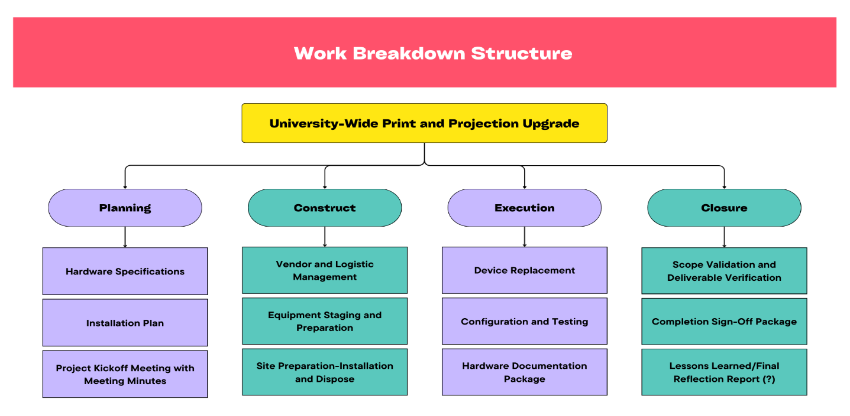
Team Time Log:
